**Gebze Technical University**

**Computer Engineering Departman**

**CSE 436 Digital Integrated Circuit**

**Homework #3**

**Berkan AKIN**

**171044073**

* Below is the 2x1 stick diagram design.

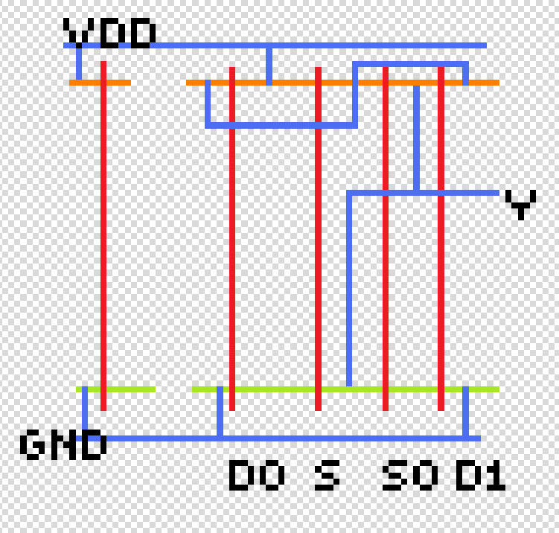

* Below is the 2x1 mux magic design.

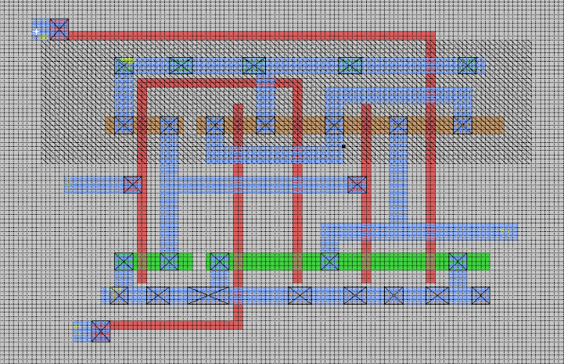

* Below is the 4x1 mux magic design.

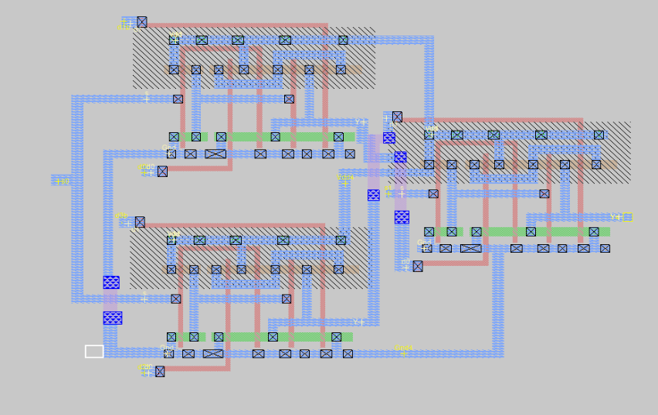

**2x1 Mux Text Case**

**S = orange Y = Green**

**D0 = red D1 = Blue**

All expected results for the 2x1 multiplexer have turned out correctly.

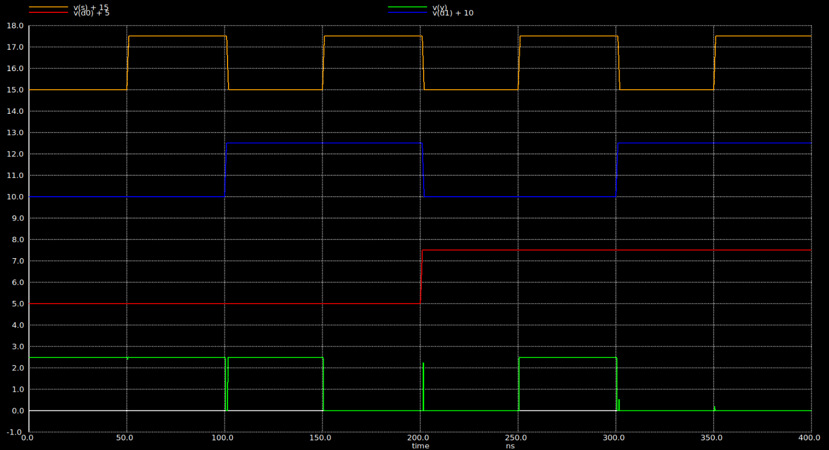

**Spice File**

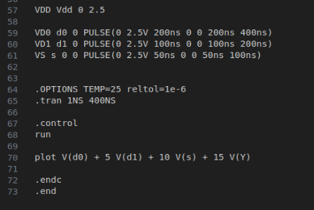

* There was an error in the combination for the 4x1 multiplexer; **the expected results couldn't be obtained**. Below are the combined forms of the 2x1 multiplexers and the test results.

S1 = Dark Red S0 = purple d3b = green d2b = orange d1 = blue d0 = red y = yellow

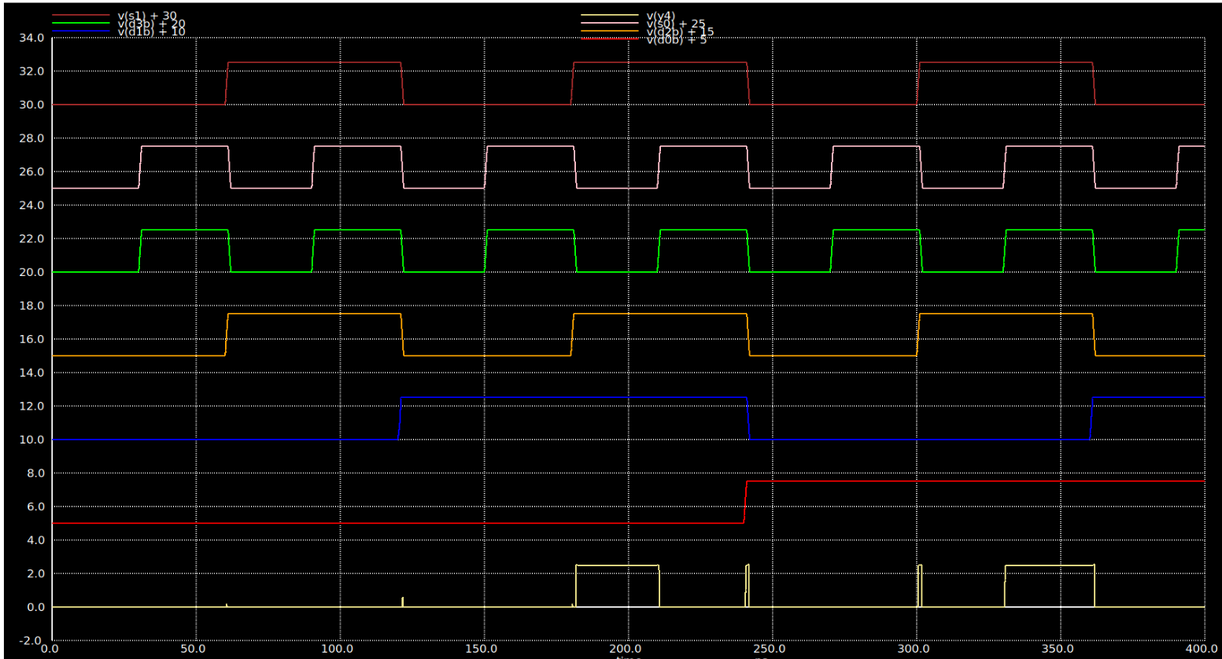

**Spice File**

